Yang Zhang, CM677

Matlab Review

September 04, 2016

%MATLAB Review

%YANG ZHANG

%Sunday, September 04, 2016

%%

%Assignment 1

x = [ones(1,3),[5:2:13],zeros(1,4)];

x(6:9) = zeros(4,1);

x(6:9)

%%

%Assignment 2

m = 1:1:7;

x = sin(m * pi / 4);

x

%%

%Assignment 3

z1 = [1:1:100];

z2 = [101:1:200];

z3 = (z2 - z1) ./ (z2 + z1)

%Assignment 4

function test(input)

% Insert comments here describing how function is to be used

if isnumeric(input) == 1

disp('The input is a number')

elseif ischar(input) == 1

disp('The input is a character')

end

>> test(3)

The input is a number

>> test('a')

The input is a character

>>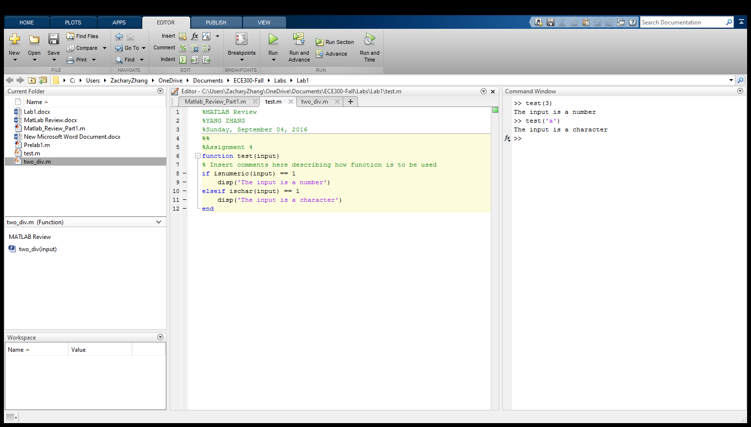

%Assignment 5

function [two_fac,remainder] = two_div(input)

%find the nearest integer for the input that divided by 2

two_fac = floor(input / 2);

%find the remainder

remainder = input - (two_fac .* 2);

>> [two_fac,remainder] = two_div(33)

two_fac =

16

remainder =

1

>> test = two_fac*2 + remainder

test =

33

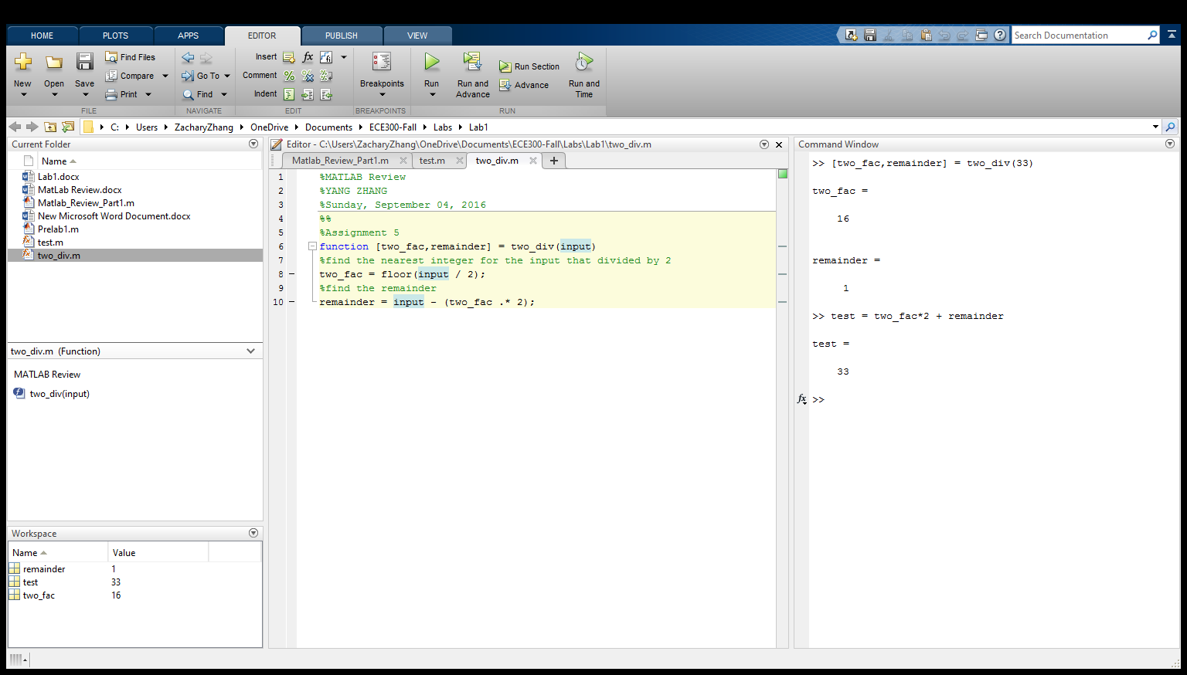

%Assignment 6

x = -1.5:0.5:1.5;

y = [-9 4 -1 0 1 -4 9];

z= x +j*y

plot(z) % complex values can be plotted

subplot(3,1,1), plot(z)

xlabel('real');

ylabel('imaginary');

title('plot1')

subplot(3,1,2), stem(abs(z))

xlabel('order');

ylabel('absolute number');

title('plot2');

subplot(3,1,3), stem(angle(z))

xlabel('order');

ylabel('angle');

title('plot3');

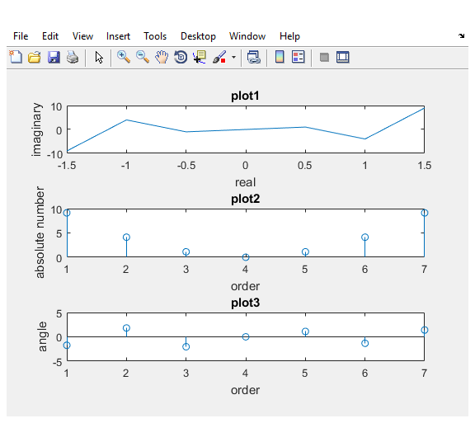

%Assignment 7

clear;

clc;

t = linspace(-2 , 20);

x1 = 20 * cos(2*pi*5000*t + 67/180*pi);

x2 = 8 * cos(2*pi*5000*t - 75/180*pi);

x3 = x1 + x2;

subplot(3,1,1);

plot(t,x1);

grid();

xlabel('t');

ylabel('x1');

title('x1 vs. t');

subplot(3,1,2);

plot(t,x2);

grid();

xlabel('t');

ylabel('x2');

title('x2 vs. t');

subplot(3,1,3);

plot(t,x3);

grid();

xlabel('t');

ylabel('x3');

title('x3 vs. t');

